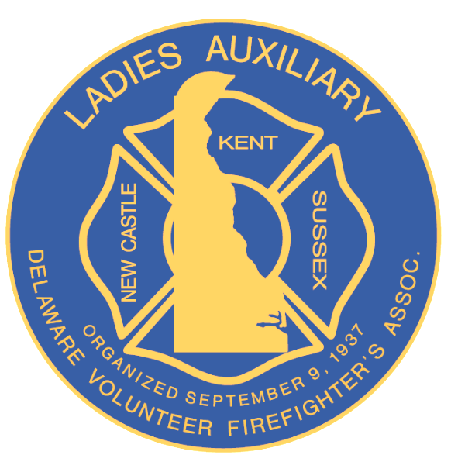

Delaware Volunteer Firefighter’s and Ladies’ Auxiliary
Mutual Relief Association, Inc.

CONFERENCE 2025
REGISTRATION

MUTUAL RELIEF MEETING
SEPTEMBER 24, 2025 @ 11:30 A.M. – 12:30 P.M.
Hyatt Meeting Place 1 & 2, Hyatt Dewey Beach

COMPANY NAME: _____________________________STATION # ________

PRESIDENT’S NAME: ___________________________PHONE # _________

DELEGATE: _______________________________________________________

ALTERNATE: _____________________________________________________

PLEASE COMPLETE AND RETURN ONE COPY OF THE REGISTRATION FORM BY JULY 15, 2025.

TO: Mary Alice Maichle
11 Blount Road
New Castle, DE 19720
MJAC28@aol.com

IF YOU HAVE ANY QUESTIONS, PLEASE CALL Mary Alice @ (302) 981-3985

